PROG8630

Design and Testing Specifications

Contents

Introduction 1

Dashboard MockUp 5

Data Source 12

Tool Selection 15

Update Plan 15

Testing Strategy 16

Project Timeline 17

Guidelines for How to Use the Dashboard 17

Work Distribution in this Stage 20

References: 21

# Introduction

This report will outline the project requirements and testing for creating the dashboard for the union of the two businesses Rogers and Netflix. Customer Data, Advertisement Expansion, Sales, and Customer Feedback are the four divisions we'll be covering. For each department, we will offer answers to two to three major questions using several key performance indicators. After focusing on each area and acquiring the necessary information, dashboards that will help you better understand the company's customer status, advertising costs, sales, and customer feedback will be created. The metrics we supplied will offer answers to the following queries.

1. **Customer Data**

Key Questions

* How many users are there per plan?
* How many users are increasing or decreasing every month?
* How much growth was noticed in Netflix subscribers after the collaboration?

KPI’s

* **Netflix and Rogers users plan choices:** Customers of Netflix and Rogers can choose from a variety of subscription packages, thus it's important to understand the plan's user ratio to gauge how popular the plan is. By contrasting several plans with clients, we may determine a plan's popularity.
* **Total users in Netflix and Rogers Joined per Month:** Since Netflix and Rogers are client-based businesses, they must be updated on their customer status every month because they acquire new consumers daily. By comparing the number of customers with their joining month, we can determine the state of each client.
* **Total users in Netflix and Rogers:** Since new users will regularly join Netflix and Rogers, they need to know the overall number of subscribers. Making the sum of all clients will yield the total number of customers.
* **Netflix subscriber Growth after the collaboration:** Rogers has approached Netflix about collaborating, and Netflix wants to know how many customers increased both before and after the partnership. By analyzing client growth before and after the partnership date, they may make that determination.

1. **Advertisement Expansion**

Key Questions

* How much investment they did in different types of advertisement.
* How much expense they did base on different provinces?

KPI’s

* **Rogers’ overall investment in various types of advertisements:** Rogers spent some money on various sorts of advertising to promote the new plan. We may compare the sums paid out by each advertisement department to determine the overall investment made in various forms of advertising.
* **Netflix’s overall investment in various types of advertisements:** Netflix spent some money on various sorts of advertising to promote the new plan. We may compare the sums paid out by each advertisement department to determine the overall investment made in various forms of advertising.
* **Rogers’ total cost of advertising in various provinces:** Rogers spent some money on marketing in several provinces to promote the new package. By adding together all forms of advertising in each province, we can determine the overall amount expended there.
* **Netflix’s total cost of advertising in various provinces:** Netflix spent some money on marketing in several provinces to promote the new package. By adding together all forms of advertising in each province, we can determine the overall amount expended there.

1. **Sales**

Key Questions

* How much monthly charge and average profit get per customer?
* How much of each company's monthly gross profit and gross sales are generated?

KPI’s

* **Rogers’ and Netflix’s total Revenue:** A corporation must know its overall income to decide how to disperse future investments among several sectors. By adding together all of the money from all of the plans, we can determine the total revenue earned by subscribers.
* **Netflix’s monthly charge by plan over profit by plan:** By comparing the average monthly fee and the average profit per user for each month, we can compare the various plans and pricing ranges offered by Netflix to have a better idea of the profit based on those plans.
* **Rogers’ monthly charge by plan over profit by plan:** By comparing the average monthly fee and the average profit per user for each month, we can compare the various plans and pricing ranges offered by Rogers to have a better idea of the profit based on those plans.
* **Rogers’ and Netflix’s total Profit:** To determine the consistency of its services, a firm must be aware of its entire profit. By adding together the total profits earned by each client according to their plan, we can determine overall profit.

1. **Customer Feedback**

Key Questions

* How many consumers out of all customers give feedback?
* How long does it typically take for them to respond to consumer feedback?

KPI’s

* **Average Ratings:** A business might seek client feedback on the services they offer in order to comprehend and alter services in accordance with consumer needs. By obtaining the total number of ratings divided by the number of ratings, we can get the average of those ratings.
* **Rogers’ percentage of consumers who provided comments overall:** Since Rogers receives feedback from its clients, it should be aware of the proportion of clients that offered evaluations. By calculating the proportion of overall feedback across all clients, we can determine it.
* **Netflix’s percentage of consumers who provided comments overall:** Since Netflix receives feedback from its clients, it should be aware of the proportion of clients that offered evaluations. By calculating the proportion of overall feedback across all clients, we can determine it.
* **Average feedback response time by Rogers:** Just as Rogers solicits feedback from its clients, it also responds to that feedback, and the amount of time it takes to do so is crucial. By counting the days between the date of feedback creation and the date of the answer, we can determine the response time. We can obtain the average response time for each month to help make it more clear.
* **Average feedback response time by Netflix:** Just as Netflix solicits feedback from its clients, it also responds to that feedback, and the amount of time it takes to do so is crucial. By counting the days between the date of feedback creation and the date of the answer, we can determine the response time. We can obtain the average response time for each month to help make it more clear.

# Dashboard MockUp

Feedback Dashboard

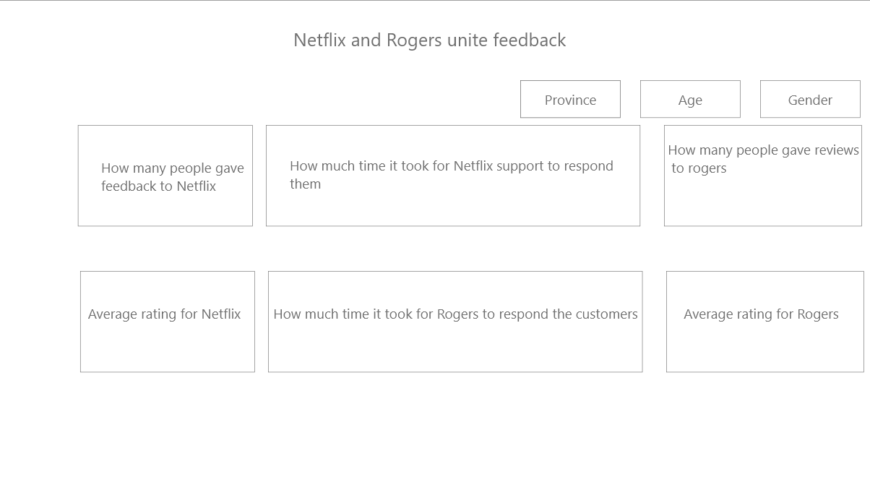

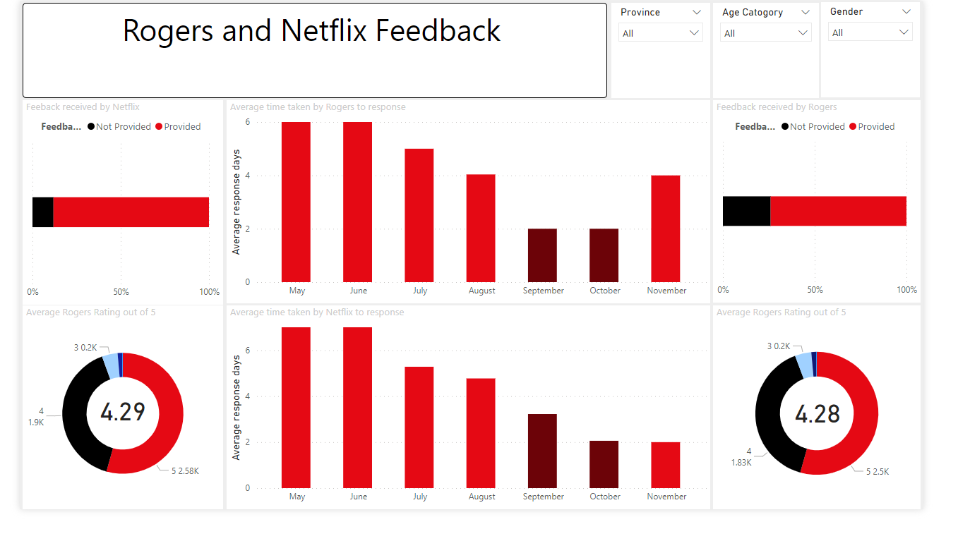

In the Feedback dashboard, we are dealing with different kinds of data regarding customer feedback

We have demonstrated all the stated KPIs for Feedback in this dashboard, here we applied three different filters one for selecting a province (Canada) which will affect all the charts in the Feedback dashboard and show data for each province you have selected, we next applied Age Category filter we have three age category in that first one is below 18, second one people between 18 to 45-year-old and last one is people who are above 45, this filter also impact all the charts in this dashboard, lastly, there is a filter for gender, we have decided to got binary genders here only male and female, this will show data for each gender you select.

For Feedback (Netflix and Rogers) visuals, we decided to use a 100% stacked bar chart to represent the percentage of people who decided to give feedback to those who decided that’s, it’s okay to not participate in any review. Each visuals represent values for each company. We selected a theme of red and black with this visualthese it is with the entire dashboard because Red color is common among both companies and white is the background which is a part of rogers and black is used as it is part of Netflix’s secondary color in their logos. Both of the charts are affected by all three filters. We tried to maintain consistency by using the same kind of chart for the same kind of data for both companies so it would be easy for the user to compare and understand the position of both companies

For Average Time taken(Roger and Netflix), We decided to use a stacked column chart for both the companies again to show consistency and we used Red and Color as it goes with the entire dashboard and both company’s themes, upon looking closely you can see that the month of October and September are darker region because they state that this was the period when the offer was valid and people were actively using it. We used a bar chart for this because there are several months and each month can be easily represented with each bar. Talking about the filters all the filters are applied to this chart, whether it be Gender, a,ge or Province, the data interpretation that the average time for response from the company side was significantly reduced as more work force was used to handle the surge in the users that recently joined, as compared to early months it took 6-7 days to get a response now it happens in two days approx.

For Average Ratings (Netflix and Rogers) We decided to use Donut charts as the number of option are only five and the donut chart can easily interpret the data while telling user in seek of an eye that what is most rating the company get and what’s second most and so on. We used Red black and blue to show data as the reason stated above, talking about the filters, so any of all the filter works with this chart and data is manipulated accordingly. There is also a numeric value in the center of the donut which represent the average rating of the company which also changes with the filter.

Customer Dashboard

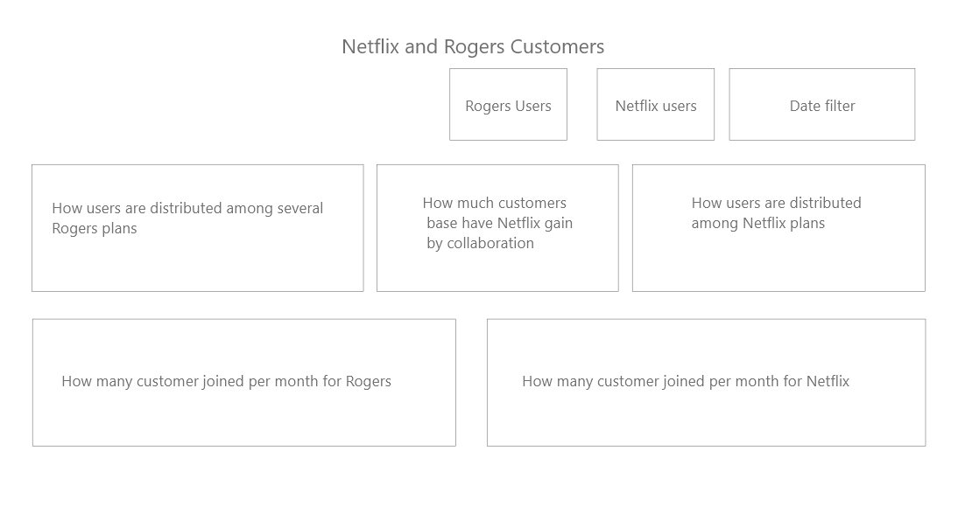

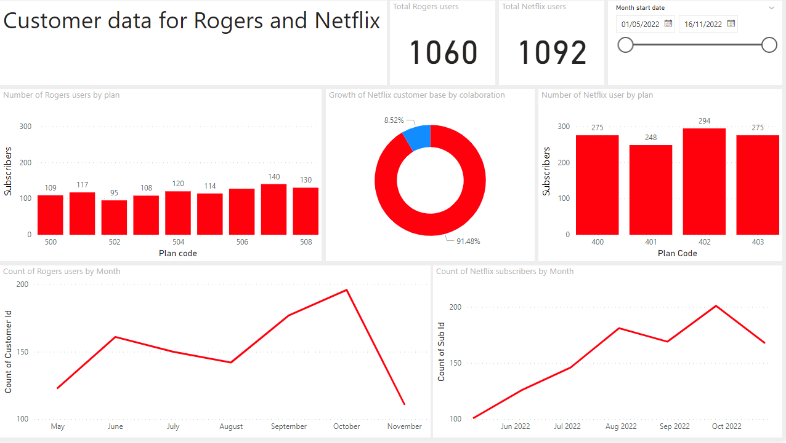

This dashboard consist of all the data that is in regard with the Customer of both the companies we created 5 different charts in this dashboard in order and one filter for date to check how many customers joined up upon that specific date subset.

For Date filter

We have created only one filter in this dashboard as it fulfill all the variation that can be done on our data for customers dashboard, it is on the top-right corner of the dashbaord

For Number of users by plan (Rogers and Netflix), for these KPI’s we decided to use Stacked Column charts, as there were multiple plans in there for rogers and bar chart would represent data more clearly and easy to understand however Netflix had only four plans but for the sake of consistency we used the same chart for Netflix as well so its easy to understand when both teams from both company sit together they can discuss easily. We again used the Red color to go along with companies color schemes and dashboard color schema. On the Y-axis we have number of users/subscribers and on the X-axis we have the different plans. About filters, we made sure that data filter can be applied to this chart.

For Count of user per month(Netflix and Rogers) In these chart we used Line chart, as the data for numerous dates and using a column or pie chart will create a lot of mess in terms of visuals to understand and user is more interested in the pattern of users joined the company rather than exact number of users joined per day. We used red color as it was part of dashboard color schema, On Y axis is the number of customer and on the X- axis there are dates showed by monthly bins. The filter of date can applied on this chart as well, and will show user joined for that subset of dates.

For Growth of Netflix customers, in this chart we decided to use a donut to represent the growth, by showing new user that joined after the plan was release in comparison to old users by total users for Netflix. Color choice is the same as it was in others, due to same reason. We decided to use donut chart so user can see the ratio of new users to old users and can know the hike in the form of percentages, this chart is affected by the date filter.

For Total Rogers user Card, this is the single selection card view that shows us the number of total Rogers users we currently have and we can use the date filter upon it.

For the Total Netflix user card, is also the single selection card view that shows the total number of Netflix users we currently have.

Advertisement Dashboard

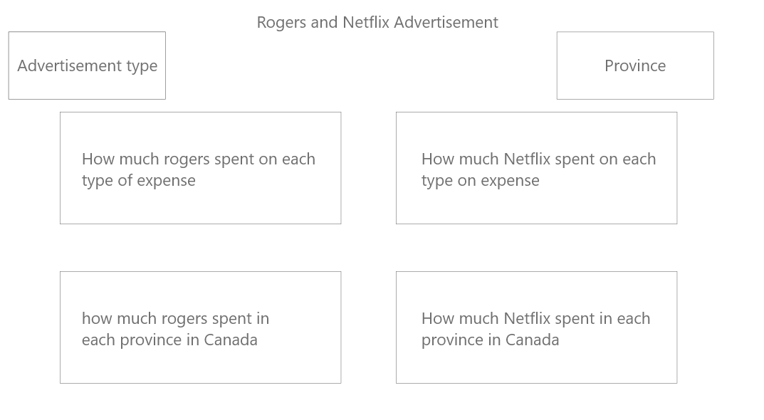

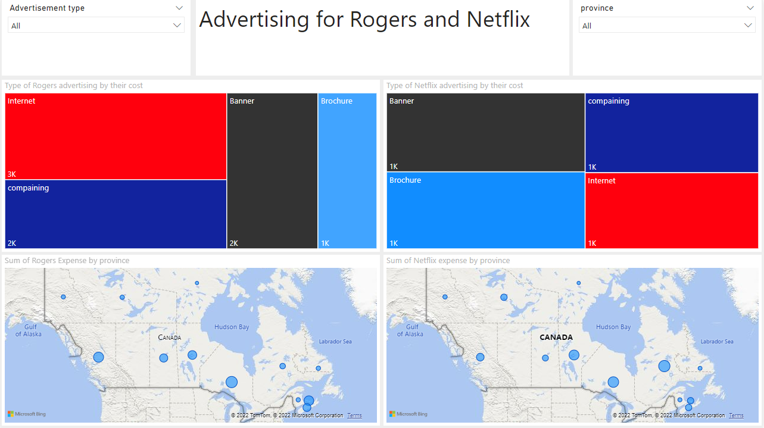

In this dashboard, we are talking about all the data and its representation that is related to both company’s advertisement. It answers four different KPIs and have four charts for it it also consists of two different filters called province and Advertisement type, from where you can select any province in Canada and see all the effect in all of the charts, and with advertisement type filter you can select each different type of advertisement and can select and see the data regarding that specific type of advertisement

For filters we have created two filters in this dashboard located on the top, at each side of the dashboard, on the left side we have an advertisement filter which has four different types of advertisement that you can choose from and on the right side there is a province filter where you can choose any province in Canada and all the charts represent accordingly

For advertisement by cost: (Rogers and Netflix), we have decided to go with Treemap chart to represent all four types of advertisement, which shows the amount of money spent on each advertisement in comparison to other advertisement types and can give an idea to the ratio of money spent on each advertisement in comparison to total money spent on advertisement.

For sum of Expense by province (Rogers and Netflix) we decided to use a Map chart to show bubbles in accordance to the size of each province’s expense on an advertisement, this chart is affected by both of the filters in the dashboard.

For Sales Dashboard

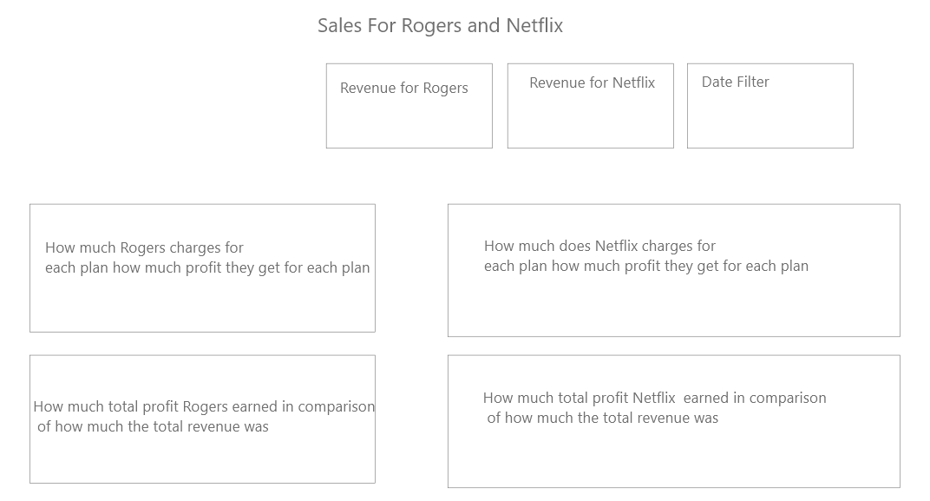

This Dashboard contains all the data regarding the sales of both of the companies by answering every KPI discussed for the sales dashboard above it has a total of four charts to answer each KPI and contains to single selection card view and one filter to filter the results we used a shade of blue in this dashboard instead of red as we have used in all other dashboards because of two reasons

First sales are something we think that both companies has the most interest in, as it directly tells profit and revenue.

Secondly, we believe the Red color is something to worry about when used in the context of finance and sales, so to look it calming and welcoming we used blue color which relates to coolness and calmness.

For Filter, we used only one filter in this dashboard that is located in the top right corner and can change the date to a smaller subset of the original date frame to have a peek of sales data with a smaller number date subset to gain additional knowledge. This filter affects every chart in this dashboard

For Average charge by plan over profit by plan: (Rogers and Netflix) we decided to use a Line and stacked column chart that can show us the profit per person as an average over plans of the company in a line format and can show us the charge they take from the user for that specific plan in a bar form. With the chart, user can easily recognize which plan benefits most the company and how much the user is charged for each plan what is the ratio of profit to the charge taken for each plan, this chart along gives three type of data, we used a shade of blue for this chart to go with the dashboard main theme, on X-axis there are plans for the companies and on the y- axis there is the amount of dollars they charge for that plan while the dark blue line shows the profit for each plan. This chart is affected by the date filter present in this dashboard.

For profit (Netflix and Rogers), we decided to go with the Gauge chart which has a minimum of 0 value and a maximum of the total revenue by that company and a target to reach to grow. This chart is affected by the date filter, user can see easily with this chart that the target has been met and everything is going well with the sales.

# Data Source

Here we are going to use simulated data that have information regarding both companies data. We are providing better understanding by explaining all type of data and their relationships with eachother.

Rogers Data:-

We have four different tables and each table includes individual KPIs.

1. Rogers feedback:- This table includes data regarding all their customers based on age and gender. We will be using this data to create Dashboard on feedback.
2. Data:- This table includes data regarding Rogers customers and their contract information as well. We will be using this data to create Dashboard on customers.
3. Sheet1:- This table includes data regarding Rogers profit margin data per customer. We will be using this data to create Dashboard on Sale.
4. Rogers advertisement:- This table includes data regarding the advertisements and their finance based on province. We will be using this data to create Dashboard on advertisement.

Netflix Data:-

We have four different tables and each table includes individual KPIs.

1. Netflix feedback:- This table includes data regarding all their customers based on age and gender. We will be using this data to create Dashboard on Feedback.
2. Netflix Subs data:- This table includes data regarding Netflix customers and their contract information as well. We will be using this data to create Dashboard on Customers.
3. Netflix sale data:- This table includes data regarding Netflix profit margin per customer. We will be using this data to create Dashboard on Sale.
4. Advertisement netflix:- This table includes data regarding the advertisements and their finance based on province. We will be using this data to create Dashboard on advertisement.

# Tool Selection

We have decided that we will use Power BI application to generate the dashboard. For the data modifications we have used Microsoft Excel application. All the relationships for the tables are being established inside Power BI.

Reason why we choose PowerBi over Tableau, is we compare all of them and then evaluate our choices

Performance

PowerBi is good in handling small data it perform better than Tableau in small data sets however when data is big Tableau is better than PowerBi, so in our cas,e our data wasn’t that big comparatively that would hander performance for powerBi we, decided to go with PowerBi

User Interface

Although Tableau has an intelligent UI but it much more complicated to use where as PowerBi has an intuitive UI which is much more comfortable for beginners to have a command on.

Data source

Tableau has more support for data source for example it can accept JSON data as well but here we care collecting all our data in form of Excel sheets hence powerBi also works just fine with excels so we decided to stick with PowerBi

Ease of Using

PowerBi has an edge over Tabeau in this case as PowerBi is based upon the Microsoft office 365 concept and user is already familiar with it whereas Tableau may have advanced options but to get to use to it is hard.

Data visualization

PowerBi support easy drag and drop functionality it provide a feature which make data more appealing while Tableau also allows user to customize there dashboard, it can transfer queries to visualizations but none of that we have to use here. Learning a new tool was not beneficial at this point

Cost

PowerBi is a free tool to use where Tableau cost money to buy, so we preferred to use PowerBi with our best shot here.

# Update Plan

Our dashboard need to fed new data, by updating the currently used Excel sheets and once sheets are update and fed new data we can easily update(refresh) over dashboards by clicking refresh button and all new changes in data will be evaluated and new charts will be shown.

Linkage is present in the dashboard, However, any more automation is not possible in our dashboard

data will be updated every month and as soon as data is entered in any table all the other tables will be updated accordingly as they are interlinked/ have relationships with each other, and Dashboards of all the table will also get updated accordingly.

# Testing Strategy

We will test our database against two major categories, which are Functional and Non-functional

Functional testing is sub-divided into two major categories called

**Validation:** In Validation, we will check our data for its correctness whether all the formulas we are using in our database are working correctly and all the aggregate functions such as SUM or Mean are producing correct outputs or not

For example we change the data for the sales for rogers and then refreshed our dashboard and checked if the data is updated and reflected properly or not

**Filters and triggers:** In Filters and triggers, we will make sure that all the filters we are using are working properly on all the charts in the dashboard or results are only reflecting partly. In triggers, we will make sure that a trigger is activated manually or automatically and work as intended in our dashboard.

For example We checked Date filters in sales and in customer dashboard where we changed the date to smalled subset and checked if all the charts in that dashboard were getting changed according to the new subset of date. We also checked the Gender filter in Feedback dashboard where we changed it to female and all the charts started to show data for only female feedbacks, it changed the rating of Netflix from 4.29 to 4.22 as female used to vote more negatively than compared to males.

Talking about Non-functional Tests

Nonfunctional Tests are again divided into two further categories called User Interface and Compatibility

**User Interface:** The user interface will majorly focus on alignment and formatting of the dashboards ie how elements are presented is everything is visible on the same display and overall dashboard is visually appealing and clear to understand. Drop-down filters and lists will be checked they should take even space and not cover other data and charts and filters are legible.

We tried to use limited number of colors as more color without any particular reason will hamper the quality of dashboard and make it harder to interpret we make sure that upon clicking on any filter it doesn’t come in way of any chart to make it harder to see changes.

We also checked that data is easily readable with correct font size (10) and used Segui font as its character are crisp clear.

**Compatibility:** We will make sure that our dashboard will look and feel good on different devices whether it will be a mobile or desktop device the dashboard will adjust itself accordingly to the display it is being projected to.

For example we opened are dashboard on the mobile devices so it could be interpreted there as well. We also checked on different screen size laptops so we can make sure it look even everywhere, after that we tried to see it on the big screen like tv connected to desktop to make sure it look good there as well.

# Project Timeline

We created a project timeline that will be followed accordingly, we have also divided the workload among the group members so everyone will have their contributions to the project. However, we will be helping each other if needed.

|  |  |  |
| --- | --- | --- |
| **Date** | **Deliverable** | **Responsible** |
| Oct 20 | Data Collected and planned | Anjan |
| Nov 4 | Data verification and modifying | Anjan, Prabhjot. |
| Nov 7 | 1st iteration of the dashboard | Prabhjot, Savita |
| Nov 11 | 2nd Iteration of the dashboard (adjust dashboard visuals and make improvements) | Geeta, Anjan |
| Nov 13 | Finalized the dashboard visuals and confirmed data,  Performed user testing. | Prabhjot, Savita, Anjan |
| Nov 18 | Dashboard submission and project report submitted | Geeta, Savita |

# Guidelines for How to Use the Dashboard

We have created 4 different dashboards and each dashboard provide different information as well.

1. Feedback Dashboard.

In this dashboard user can use different filters which are Province, Age and Gender and get result based on the filter that they have applied. By default they are selected as all. All the filters are applied on all charts.

1. Province:- By default it selects all the province which is why the data shown in the charts are from all province. We can choose particular province and get the result based on the province selected.
2. Age:- By default it selects all the Age which is why the data shown in the charts is for all age customers. We have three different category which are below 18, 18 to 45 and 45 above. We can select particular option from above and get data based on our selected option.
3. Gender:- By default it selects both the genders which is why the data shown in charts are for all genders. We have two categories which are male and female. Based on selected option we will get output.
4. Customer Dashboard.

In this dashboard user can use date filter to select a period of time in which the charts below will show result. We can choose the starting date of month as an example the default date period is selected as 01/05/2022 to 16/11/2022. Which is why all the charts shows output based on the period we have selected.

1. Advertising Dashboard.

In this dashboard there are two filters we have used which are Advertisement type and province. There are total four different advertisements which are Internet, Campaigning, Banner and Brochure. There are different province just like feedback dashboard and we can select particular from them and get filtered result.

1. Sale Dashboard.

In this dashboard user can use date filter to select a period of time in which the charts below will show result. We can choose the starting date of month as an example the default date period is selected as 01/05/2022 to 16/11/2022. Which is why all the charts shows output based on the period we have selected.

# Work Distribution in this Stage

We are four members in our team Anjan, Prabhjot, Geeta, and Savita we try to divide all of the work equally by giving head positions to each person for each department to handle its responsibilities promptly. The responsibilities were assigned in the following manner.

Data acquisition and filtering: Anjan and Prabhjot

Dashboard creation: Anjan Shah

Data source: Prabhjot Singh

Word file creation and filling up details: Geeta and Savita

Dashboard 1st iteration meeting lead: Prabhjot Singh

Dashboard 2nd iteration meeting lead: Anjan Shah

# References:

[1] “Mockaroo - Random Data Generator and API Mocking Tool | JSON / CSV / SQL / Excel,” [www.mockaroo.com](http://www.mockaroo.com) Retrieved on 18 November 2022. By Team 4 <https://www.mockaroo.com/>

To get the mock data for sales and customer tables

2)

<https://www.simplilearn.com/tutorials/power-bi-tutorial/power-bi-vs-tableau>

to choose between tableau and Powerbi as an option to make our dashboard Retrieved on 20 November 2022 By Team 4

3)

<https://www.datapine.co.uk/kpi-examples-and-templates/customer-service>

To understand Customer key performance KPI’s retrieved on 22 November 2022

By Team 4

4)

<https://www.netsuite.com/portal/resource/articles/accounting/sales-kpis.shtml>

what could be sales KPI’s. Retrieved on 23 November 2022 by Team 4

‌5)

<https://dashthis.com/blog/top-5-advertising-and-paid-kpis/>

To understand advertisement KPI’s Retrieved on 23 November By Team 4